Safety Car / Virtual Safety Car Risk Estimation

Formula 1 is a sport that involves significant uncertainty and dynamic incidents. Given such dynamic behavior, it is crucial to consider events that can alter strategic decisions and adopt choices that affect the drivers’ overall performance and race times. Safety Car (SC) or Virtual Safety Car (VSC) events can alter pitstop costs, race pace, interval between cars and the performance of pre-decided strategies. Since such events can influence and alter the strategy, it is critical to estimate the likelihood of an SC or a VSC occurring in the near future. The proposed model estimates the probability of an SC or a VSC, considering the current race state stored in the system. The probabilities generated by this model will be provided to the Race Simulation Layer, enabling the generation and evaluation of multiple race strategies based on the current state.
The task is to create a probabilistic risk estimation model whose objective is to estimate the likelihood of a Safety Car (SC) or a Virtual Safety Car (VSC) event occurring within the next 1, 3, 5, or 10 laps. The Race State provides the data on the current race conditions, including the track temperature, the gaps between drivers, the sector times, the traffic conditions on the track, recent yellow flags and retirements among other race state variables. Based on the information provided and historical data, the model estimates the risk of a Safety Car or a Virtual Safety Car occurring. Both events are considered mutually exclusive as both events have varying consequences on the race strategies and the decisions to be adopted.
Safety Car and Virtual Safety Car events occur infrequently but can have a substantial impact on the race. Thus, this problem can be approached as a rare event prediction problem. Previous research on rare event prediction identifies class imbalance and limited availability of data as a major challenge when developing prediction models. Heilmeier et al. integrated probabilistic SC and VSC events into race simulations using probabilities derived from historical race data. However, the probabilities used by Heilmeier et al. are determined from historical distributions and race progress, without taking into account the evolving race state including weather conditions, traffic conditions, and related race state variables. Thus, there is a need for the development of a rare event estimation approach that combines historical evidence with the current race state to estimate the likelihood of future events.
The proposed approach improves upon pre-existing work by combining historical incident probabilities and the current race state. The model dynamically adjusts the estimated risk according to the evolving conditions of the race.
- Historical Risk
Historical probability is calculated based in the circuit and the current interval of the race. The race is divided into predefined race progress intervals, allowing the model to understand the differences in event occurrence throughout the entire race. For an event type $e$, where $e∈\left\{ , SC,VSC\right\}$, the historical probability is represented as:

where $C$ represents the circuit and $L_{t}$ represents the race-progress interval at lap $t$.

- Race State Risk Update
The historical probability is combined with current race state features. These features represent the current conditions of the race, including the number of close battles (within 1 second), the gap in which the field is spread, recent yellow flags and additional race related variables. The risk is estimated using a logit model:
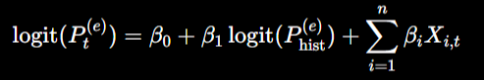
where $P_{t}^{\left(e\right)}$is the estimated one-lap probability of event $e$, $X_{i,t}$represents the $i$-th race-state feature at lap $t$, and $β_{i}$represents the corresponding model coefficient.

- Multi Horizon Risk Estimation
The model does not limit itself to predicting the risk of a SC or VSC event occurring within a single horizon, instead estimating the risk across multiple horizons to allow for flexible assessment of impact of future events on the race strategy.

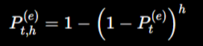
where $h∈\left\{1 , 3 , 5 , 10\right\}$.

- Probability Calibration
Probabilities are calibrated before they are passed to the race simulation layer in order to ensure that the predicted probabilities reflect the likelihood of a SC or a VSC event occurring.

The primary improvement over prior work is the incorporation of machine learning techniques that use the current race conditions to estimate the SC and VSC risk. While historical information can estimate the tendency of a SC or VSC based on the track, the machine learning based model can account for the real time race conditions. The estimated risk can thus update as the race progresses instead of relying solely on pre-calculated estimations.

Safety Car Prediction Metrics
Horizon | Metric | Historical Baseline | Logit Update | XGBoost (Calibrated)
1 Lap | Brier Score | 0.009324 | 0.009241 | 0.009260
 | PR-AUC | 0.009324 | 0.018852 | 0.009826
 | Max-F1 | 0.018476 | 0.057971 | 0.024845
3 Laps | Brier Score | 0.027353 | 0.026672 | 0.026708
 | PR-AUC | 0.027353 | 0.038793 | 0.052634
 | Max-F1 | 0.053250 | 0.085227 | 0.132075
5 Laps | Brier Score | 0.045871 | 0.044004 | 0.044028
 | PR-AUC | 0.045872 | 0.058143 | 0.050415
 | Max-F1 | 0.087719 | 0.116667 | 0.095808
10 Laps | Brier Score | 0.078899 | 0.073443 | 0.072703
 | PR-AUC | 0.078899 | 0.080443 | 0.124207
 | Max-F1 | 0.146259 | 0.163031 | 0.182292

Virtual Safety Car Prediction Metrics
Horizon | Metric | Historical Baseline | Logit Update | XGBoost (Calibrated)
1 Lap | Brier Score | 0.005439 | 0.005423 | 0.005456
 | PR-AUC | 0.005439 | 0.006822 | 0.005626
 | Max-F1 | 0.010819 | 0.018957 | 0.014545
3 Laps | Brier Score | 0.013677 | 0.013577 | 0.013528
 | PR-AUC | 0.013677 | 0.015628 | 0.014816
 | Max-F1 | 0.026984 | 0.046948 | 0.038012
5 Laps | Brier Score | 0.020851 | 0.020628 | 0.020467
 | PR-AUC | 0.020851 | 0.022694 | 0.026611
 | Max-F1 | 0.040850 | 0.056911 | 0.092308
10 Laps | Brier Score | 0.033945 | 0.033752 | 0.032875
 | PR-AUC | 0.033945 | 0.030653 | 0.024158
 | Max-F1 | 0.065661 | 0.078517 | 0.066607

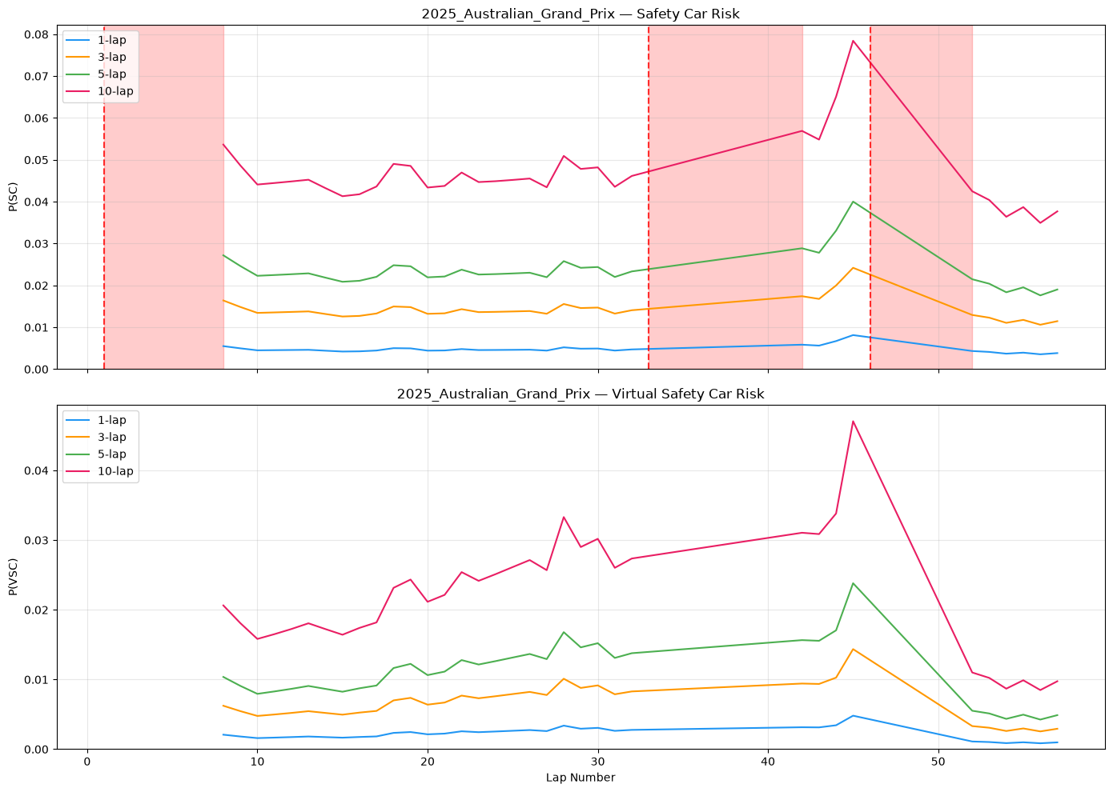

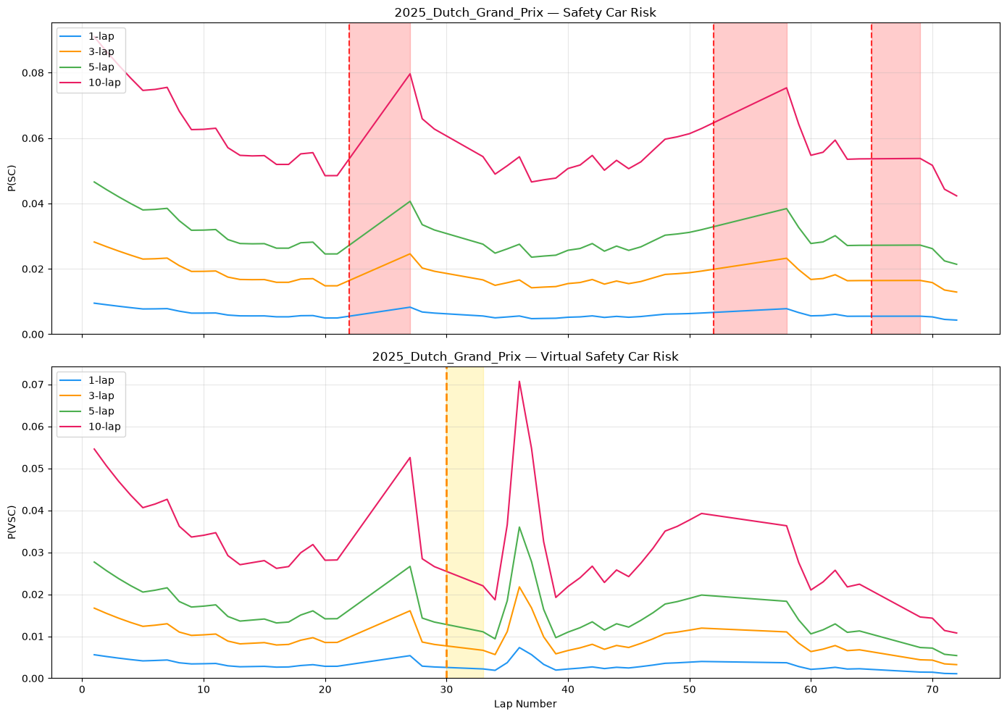
The proposed approach can thus combine historical probabilities with the current race conditions to provide dynamic probability estimations across horizons. These are then used by the race simulation to evaluate multiple strategies under risk driven and uncertain conditions.

